National & Inter-School Achievements

- IIT Madras – Junior Make-a-thon: Amit, Kavyansh, and Racheet (Class XI-A) participated in the Junior Make-a-thon on the theme “Viksit Bharat – 2047”, qualified up to the second round, and received certificates for innovation and research-based problem solving.

- Nanhi Chhaan National Essay Contest 2025: Tulsi Thakur and Shifa (Class XI) represented VIDYA School at the national level and attended a Personality Development and University Exposure Programme at NIIT University, Neemrana.

- Innoventure Innovation Platform: Students from Grades I–IX participated in national innovation assessments. VIDYA School was awarded the National Innovation School Ranking – Rank 3 in Haryana, in collaboration with E-Cell, IIT Hyderabad.

- Inter-School Astronomy Quiz: Rachit Kumar Ray (XI-A) and Gaurav Raturi (XII-A) won a Consolation Prize at the National Science Centre, New Delhi; other participating students received certificates.

- “Traders 3.0” – K.R. Mangalam University: Kavyansh and Shreya secured Second Position in the Chemistry Magic segment and received a cash prize and certificate.

- Painting Competition – National Science Centre: Multiple students secured 1st and 3rd positions across junior and senior categories, reflecting strong creative excellence.

- Leadership Recognitions – Ms. Ila Sarin was honored with the Future Ready Leadership Award and the Institutional Leadership in Entrepreneurship Award (Youth Ideathon 2025) for her contribution to STEM, innovation, and entrepreneurial education.
- Active engagement with tech companies, educational institutions, and partner organizations to mobilize resources, mentorship, and funding for the Discovery & Innovation Hub.

SPORTS ACHIEVEMENTS

Sports Achievements
VIDYA School takes immense pride in the remarkable accomplishments of our students at the prestigious Khel Yatra 2025, held in February 2025. We got 2nd position (received a trophy & 25 medals in different Category) out of 22 participants from different schools. The event witnessed enthusiastic participation from young athletes across various age categories, providing a competitive platform to showcase talent, discipline, and sportsmanship. Our students displayed exceptional determination, skill, and perseverance, bringing laurels to the institution.
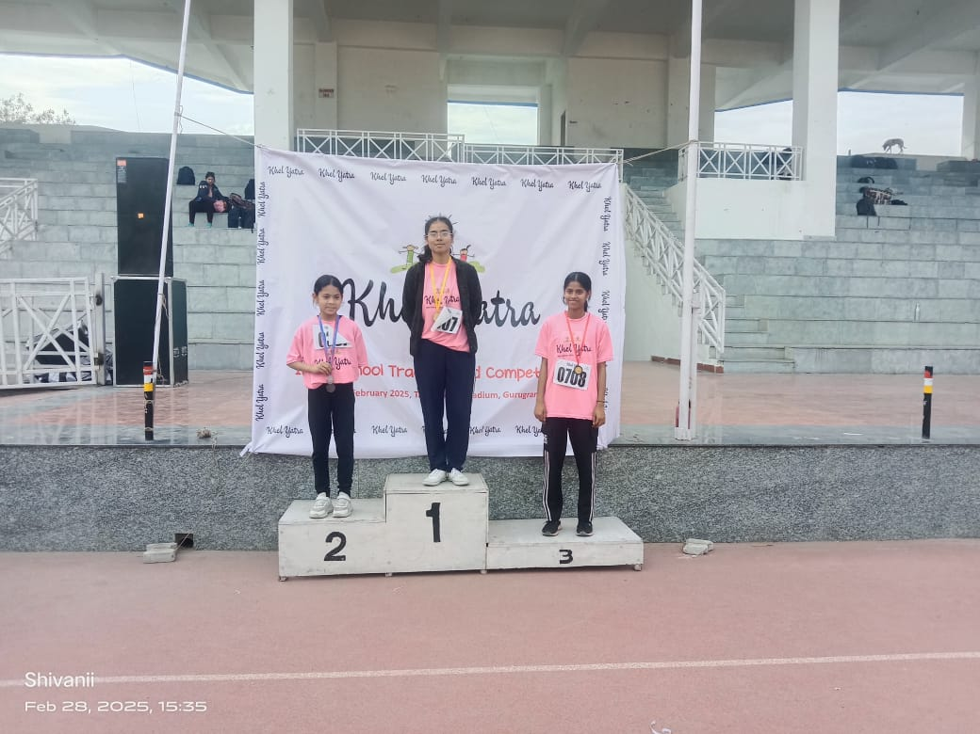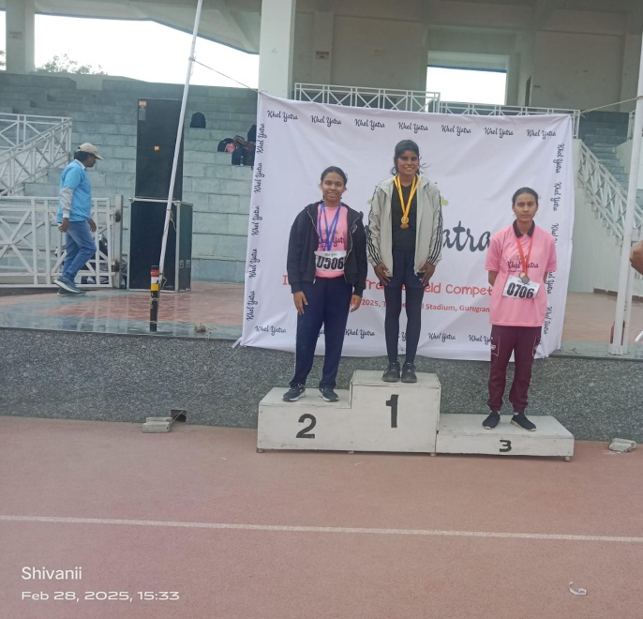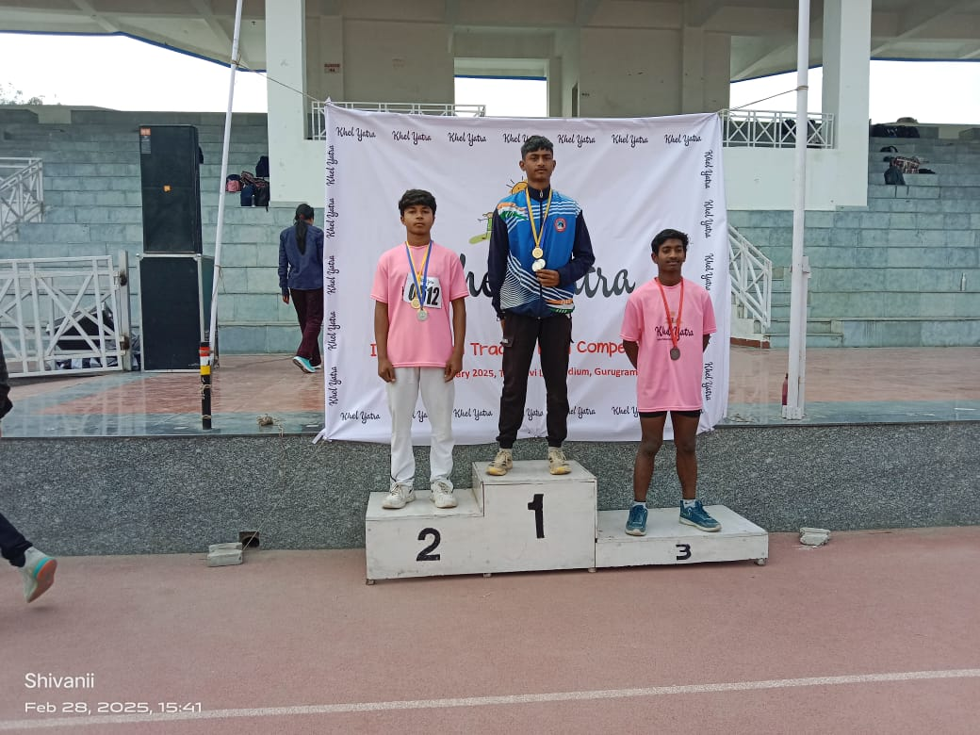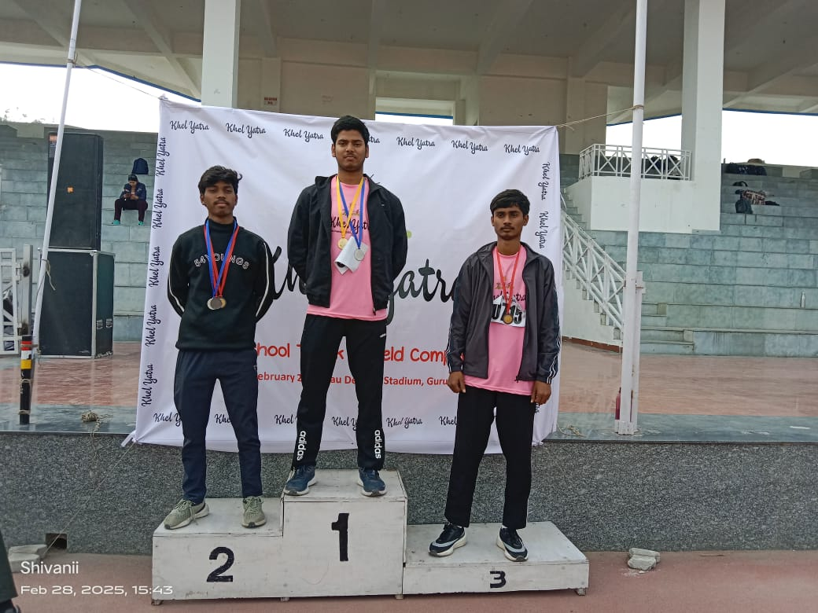

CBSE CLUSTER ATHELETIC BOYS 2025)
The following outstanding achievements were recorded:
- ( Shivam Kumar achieved a Gold Medal in the Triple Jump (Under-17 Category). His powerful performance, technical precision, and consistent focus enabled him to secure the top position in his category.
- Anant earned the Silver Medal in the Triple Jump (Under-19 Category). His commendable effort and competitive spirit were clearly reflected in his impressive performance.
- Ajay secured the Silver Medal in the Long Jump (Under-14 Category), demonstrating remarkable agility and coordination at a young age.
- Ajay further added to his achievements by winning the Bronze Medal in the 200-Metre Race (Under-14 Category), showcasing his speed, endurance, and athletic versatility.
- Abhishek claimed the Bronze Medal in the 100-Metre Race (Under-14 Category). His swift acceleration and determined finish earned him a well-deserved place on the podium.
In recognition of their exceptional performances, Shivam Kumar, Anant, and Ajay successfully qualified for the National Level Athletics Championship, marking a significant milestone in their sporting journey.
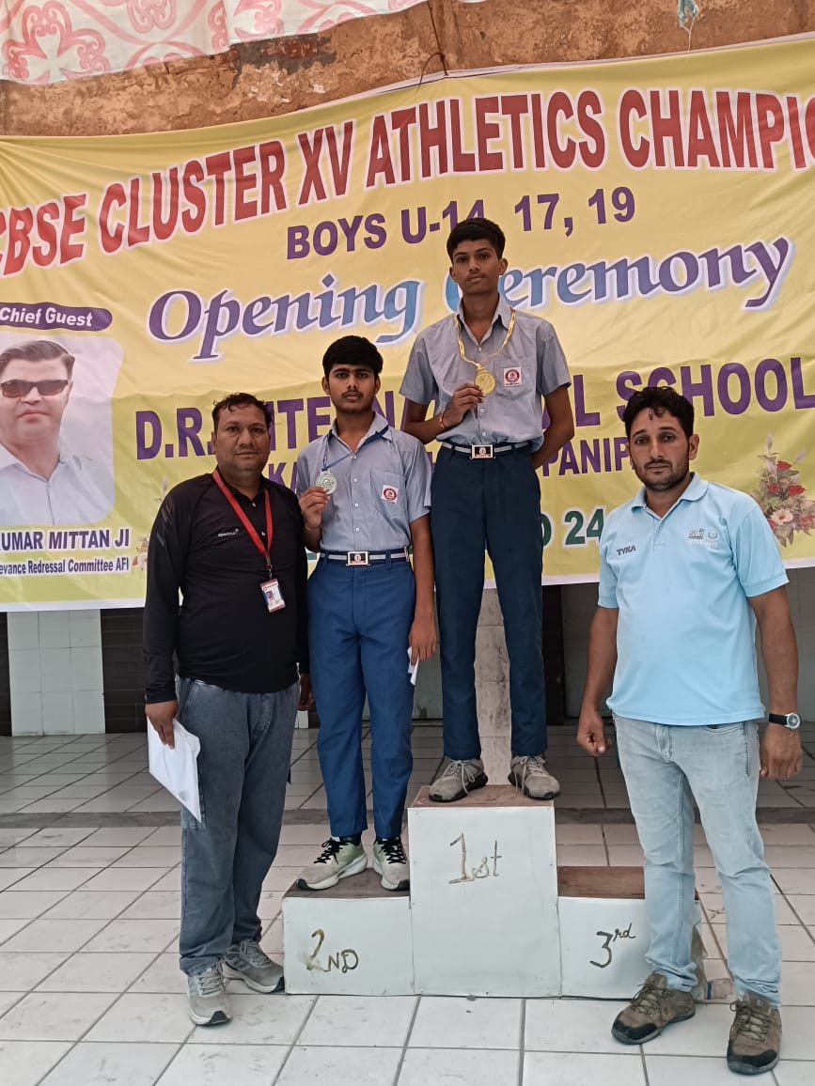
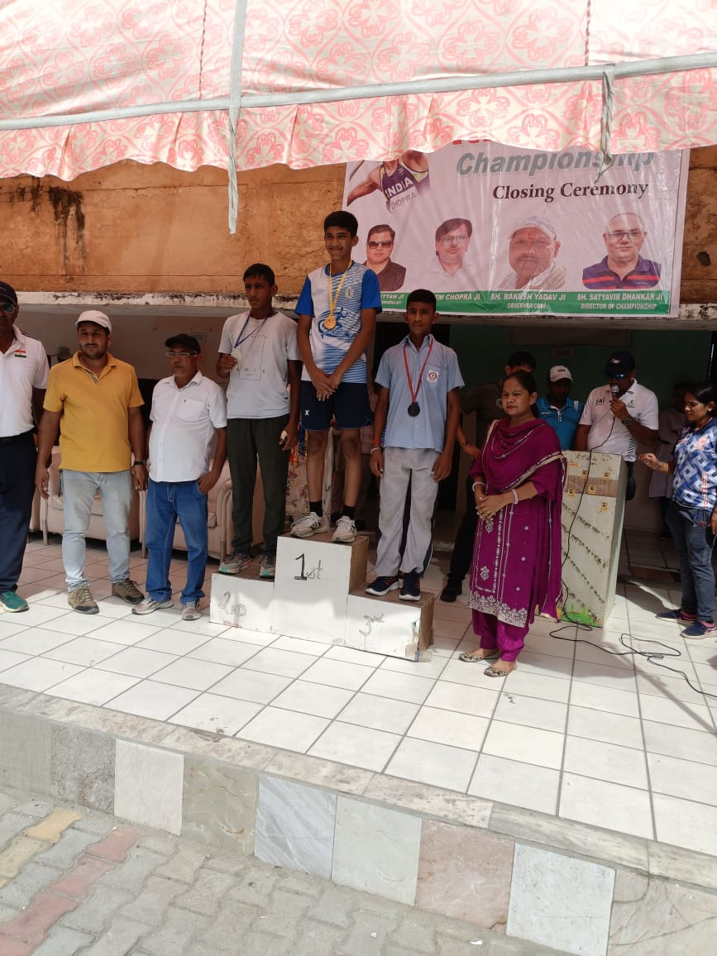
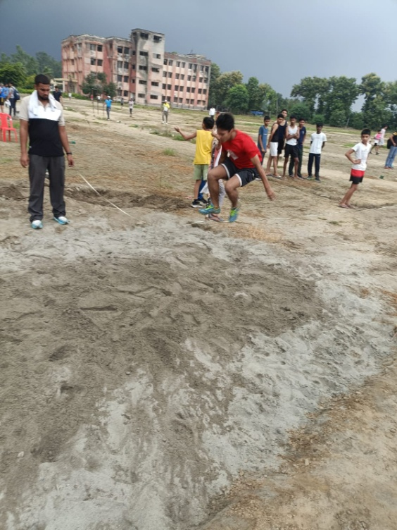
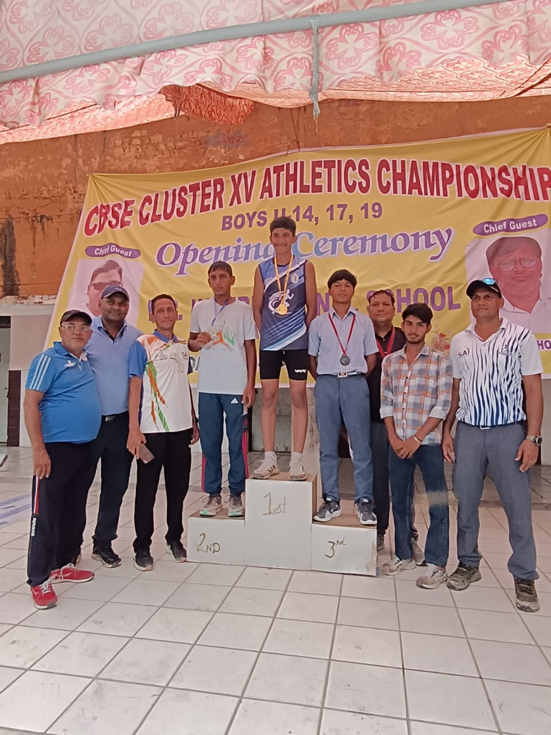

III) The National Level Athletics Event was organized in October 2025 at St. Atulanand School, Varanasi. Our qualified students proudly represented the institution at this esteemed national platform, competing alongside talented athletes from across the country. Their participation at the national level reflects not only their individual dedication and hard work but also the continuous guidance and encouragement provided by their coaches and mentors.
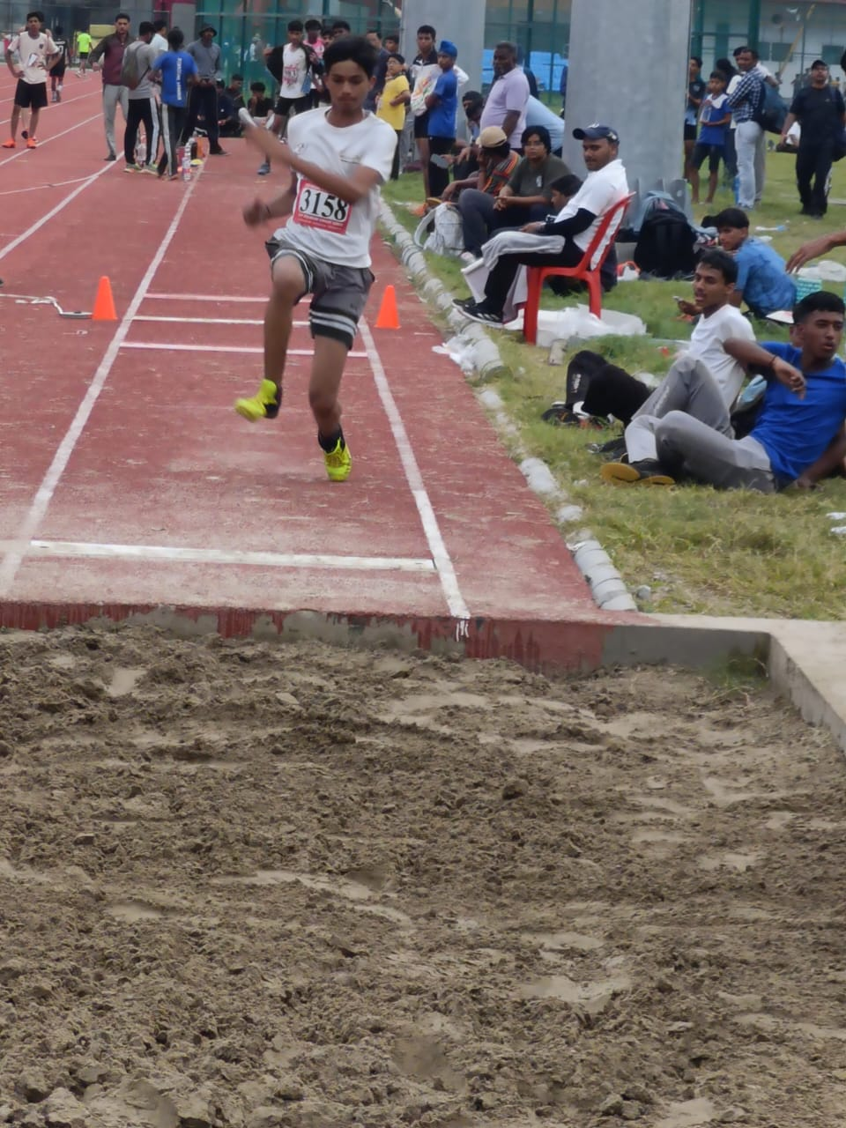
These achievements stand as a testament to the school’s commitment to nurturing athletic excellence, promoting physical fitness, and fostering a spirit of healthy competition among students. We extend our heartfelt congratulations to all the achievers and wish them continued success in their future sporting endeavors

.

AWARDS AND RECOGNITION FOR YEAR 2024-25
Sr. No | Date | Award | Brief - Name of the event, venue and description | Class/Name of the Student
1 | 4 Dec 2024 | Qualified National In New Young Robotics Challenge | Robo Vidya - Amity International School Gurgaon | Rakesh 10B Asim 10B
 | 27 to 29 sep 2024 | Cbse Athletic Cluster
2 | 27 to 29 sep 2024 | 1 gold medal ,7 silver medal | heritage school of learning | sumit mandal ,shivam Kumar ,Abhishek ,ajay ,lakshay rana ,sumit mandal ,satyam & karan
3 | 27 to 29 sep 2024 | Sumit mandal got gold in 200 mtr | jhajjar haryana
4 | 27 to 29 sep 2024 | Shivam Kumar got silver medal in tripple jump
5 | 27 to 29 sep 2024 | Relay team got silver medal |  | Ajay ,Abhishek , lakshay ,sumit manda( satyam extra ).
6 | 27 to 29 sep 2024 | Karan got bronze in long jump ( u-19)
7 | 27 to 29 sep 2024
8 | Sep 2024 | cbse athletic games ( girls )
9 | Sep 2024 | Deepika got silver medal 100 mtr ( u-19) | rao Nihal Singh near kosli haryana | Deepika mandal ( 12 b)
10 | 6 to 9 oct 2024 | cbse national athletic ( participation) | sant atulanand school varanasi ( u.p) | Deepika mandal ,sumit mandal8b ,shivam Kumar 10
11 | 28.feb 2025 | khel yatra vidya got second position & got a trophy | tau devilal stadium gurgaon | ajay , lakshay,Abhishek ,sumit mandal ,shivam Kumar ,shivam mishra ,neha & tannu ( students got several medal in different events )
12 | 5th August 2024 | Awarded for achieving First Place | Blinkit & Feeding India Art Competition  Venue: VIDYA School, Gurugram (Haryana, India) Blinkit selected the best art out of all the submissions and print it on their delivery bags. | Aradhya Prajapati class:- VIII B
13 | Mar-24 | 1st and 2nd | online (YOUNG ARTISTE COMPETITION) | Tannu kumari,Khushi kumari

Young Innovator Shaping the Future: Vaishnavi Upadhyay
Vaishnavi Upadhyay, a promising tech and robotics student of Vidya School GURUGRAM, is steadily making her mark in the world of innovation through dedication, creativity, and a passion for problem-solving. Her journey in robotics began with LEGO Mindstorms NXT and EV3 and Spike Prime kits, where she built a strong foundation in programming, logical thinking, debugging and teamwork.
In 2024, Vaishnavi participated in the World Robot Olympiad (WRO) Regional Competition at KUNKAPSSKOLAN School and successfully qualified for the WRO Nationals in the Junior Category, held in Ahmedabad, Gujarat. Encouraged by this achievement, she returned stronger in WRO 2025, competing in the Robomission Category, where her team secured a better rank. As the coder of her team, Vaishnavi played a vital role in designing and programming the robot, demonstrating technical excellence and leadership.
Her achievements continued at Robotex Nationals India, where she earned 2nd Rank in the Girl Firefighter Category. In the same competition, her team advanced into the Top 10 in the Entrepreneurial Category, highlighting her innovative thinking beyond robotics. Her exceptional performance led her to represent India at Robotex International, one of Europe’s most prestigious robotics competitions, where she worked confidently with a new platform, Arduino, and delivered an impressive performance on the global stage.
Vaishnavi’s passion extends beyond competitions. During Vidya’s Annual Day, she and her peers developed a robotic solution for earthquake rescue, designed to locate trapped individuals, deliver basic necessities, and send real-time location data. She later presented projects such as an automated wheelchair and an obstacle-avoiding machine at the Education Summit 2026.
With unwavering determination and a vision to use technology for societal good, Vaishnavi Upadhyay continues to pursue mastery in robotics, aspiring to make a meaningful impact on the world through innovation.

From Curiosity to Creation: Omkar Mishra’s Robotics Journey
Omkar Mishra, a Class 9 student, is an inspiring example of how curiosity and effort can shape a meaningful STEM journey. From an early age, Omkar was curious about machines and technology. Instead of only asking questions, he decided to explore the answers by learning robotics in school. School takes his All responsibility whether it was travelling to place where competition was held or to the training centre. At every single step school help him. VIDYA SCHOOL (GURUGRAM) is not a school it is starting place of new mindset and success from OMKAR MISHRA started his journey Have you ever wondered how robots think or move? That same curiosity became the starting point of Omkar’s journey.
During his school years, Omkar actively participated in many robotics competitions such as the World Robot Olympiad (WRO) 2024 and 2025 and IRO. These competitions gave him opportunities to test his ideas, face challenges, and improve his skills. Are competitions only about winning prizes, or are they also about learning and growing? For Omkar, they became powerful learning experiences.
Omkar mainly works as a builder and debugger. He enjoys building robots from basic parts and then fixing errors when something does not work properly. When a robot fails, he does not feel discouraged. Instead, he asks himself, “What can I learn from this mistake?” This positive attitude helps him improve every time.
What makes Omkar unique is his way of thinking. His ideas are simple, practical, and useful, focusing on solving real-life problems. Can one small idea make a big difference? Omkar believes it can. His journey shows that innovation starts with curiosity and grows with patience. Reading his story makes us ask ourselves: What can we build if we start believing in our ideas today?

Aaryan Kumar: Growing Through Robotics and Coding

Aaryan Kumar, a Class 9 student at Vidya School, has always been curious about how things work. That curiosity grew into a passion for robotics and STEM, leading him to explore coding, problem-solving, and teamwork at school. What started as simple experimentation with robots soon became a journey of learning and achievement.

Vidya School provides students with hands-on training in robotics, giving Aaryan the guidance and resources he needed to develop his skills. As part of his school’s robotics team, he worked as a coder, designing programs that made robots perform tasks efficiently and accurately. Hours of testing, improving code, and troubleshooting strengthened his technical skills and logical thinking, making him a key contributor to his team.

Aaryan has participated in several competitions, including World Robot Olympiad (WRO) and IRO. During WRO 2024–25, his team performed impressively, and in 2024, they successfully qualified at the Regional Championship level for the Nationals. These experiences gave him practical exposure to robotics, teamwork, and real-world problem-solving, while boosting his confidence and perseverance.

What makes Aaryan’s journey inspiring is his willingness to learn from every challenge. Success motivates him, while setbacks teach him patience and resilience. His story reflects the true spirit of STEM—curiosity, continuous learning, and innovation.

As he continues exploring robotics and coding, Aaryan Kumar is not only achieving personal milestones but also inspiring other students at Vidya School to follow their interests and work hard. His story shows that with passion, persistence, and creativity, young learners can turn their ideas into achievements.

